
Lesson 7 Teacher's Key: On the Move
Scratch - Instructor Reference Only
VIDEO GAME CREATION

What This Lesson Teaches
Continuous per-frame movement inside a forever loop, and a second independent condition (position threshold) inside that same loop that removes a clone without ever broadcasting enemy hit. This is the first lesson where two separate "remove this instance" pathways coexist in the same script.

Level 1 - Full Worked Solution
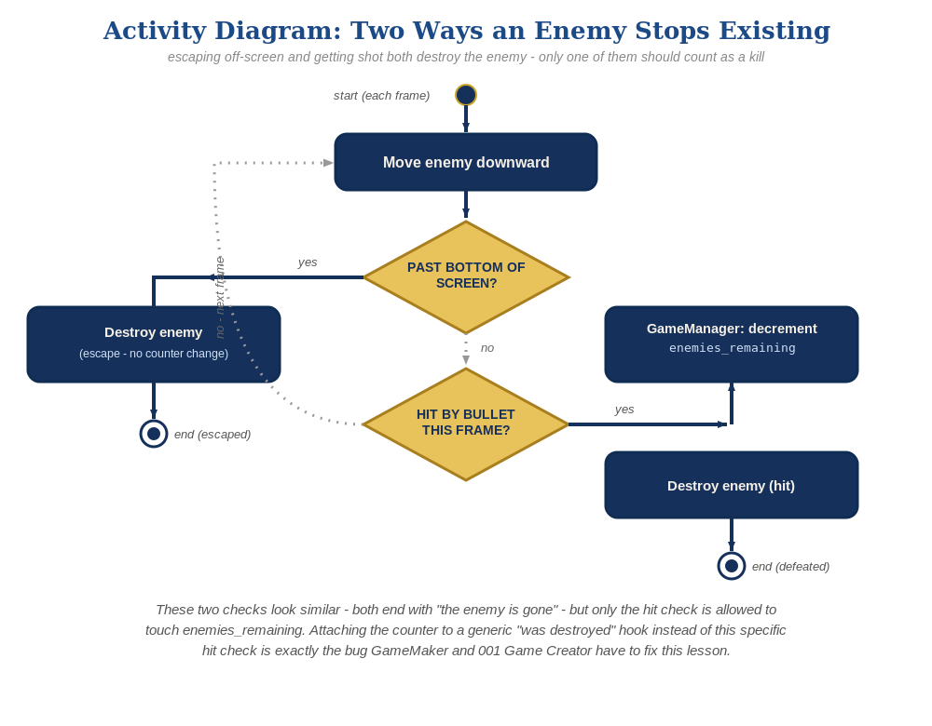
The general escape-vs-hit distinction behind this week's exercise - the same shape in every engine, whatever the exact code or blocks look like.
- "change y by -1" goes first in the forever loop, before the touching check, so movement happens every frame regardless of collision state.
- The bottom-of-screen check ("y position < -170") is a second, independent if-block in the same forever loop, using delete this clone with no broadcast and no reference to enemies_remaining.
- Scratch's stage is 360 units tall (y from -180 to 180); -170 leaves a small margin so the enemy is fully off-stage before deletion, avoiding a visible pop.

Why This Structure
- Scratch's Lesson 6 retrofit already moved win-counting off the Enemy sprite entirely, onto a dedicated GameManager sprite that listens for an enemy hit broadcast - so this lesson's escape-cleanup check only has to avoid ever broadcasting that message, not avoid touching a shared variable directly. There's no 'on clone deleted' event for GameManager to accidentally overload the way GameMaker and 001GC's generic destroy hooks can be.
- Keeping both checks in the same forever loop (rather than splitting into two scripts) is fine here because each check's action (delete this clone, with only one of the two also broadcasting) is self-contained and neither one depends on the other's outcome.
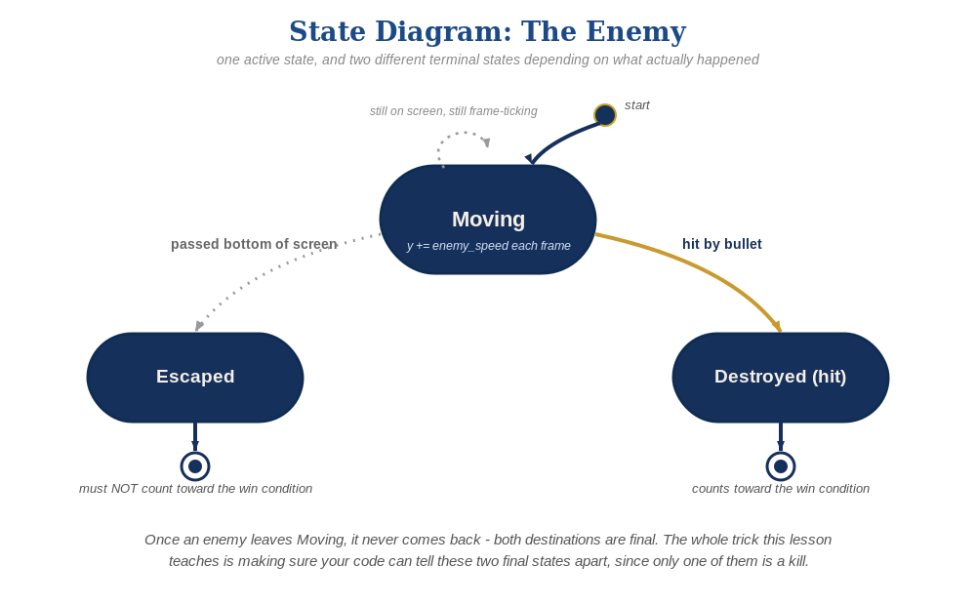
The enemy's two possible endings this week - only one of them should count as a kill.

Level 2 / Level 3 Talking Points
- Ask students: what would happen if the y<-170 check ran before the touching check instead of after? (Nothing bad in this case, since both branches end in delete this clone and only one runs per frame - a good moment to discuss when ordering matters and when it doesn't.)
- Level 3 visual: varying speed by enemy_number produces a fanned-out descent that reads as more three-dimensional/organic than uniform movement.

Common Student Mistakes
- Placing "change y by -1" outside the forever loop (runs once at clone creation, enemy never actually moves).
- Using > instead of < in the bottom-check comparison (enemy deletes itself immediately since starting y is greater than -170).
- Forgetting Scratch's y-axis convention (up is positive) and moving enemies up off the top instead of down.

